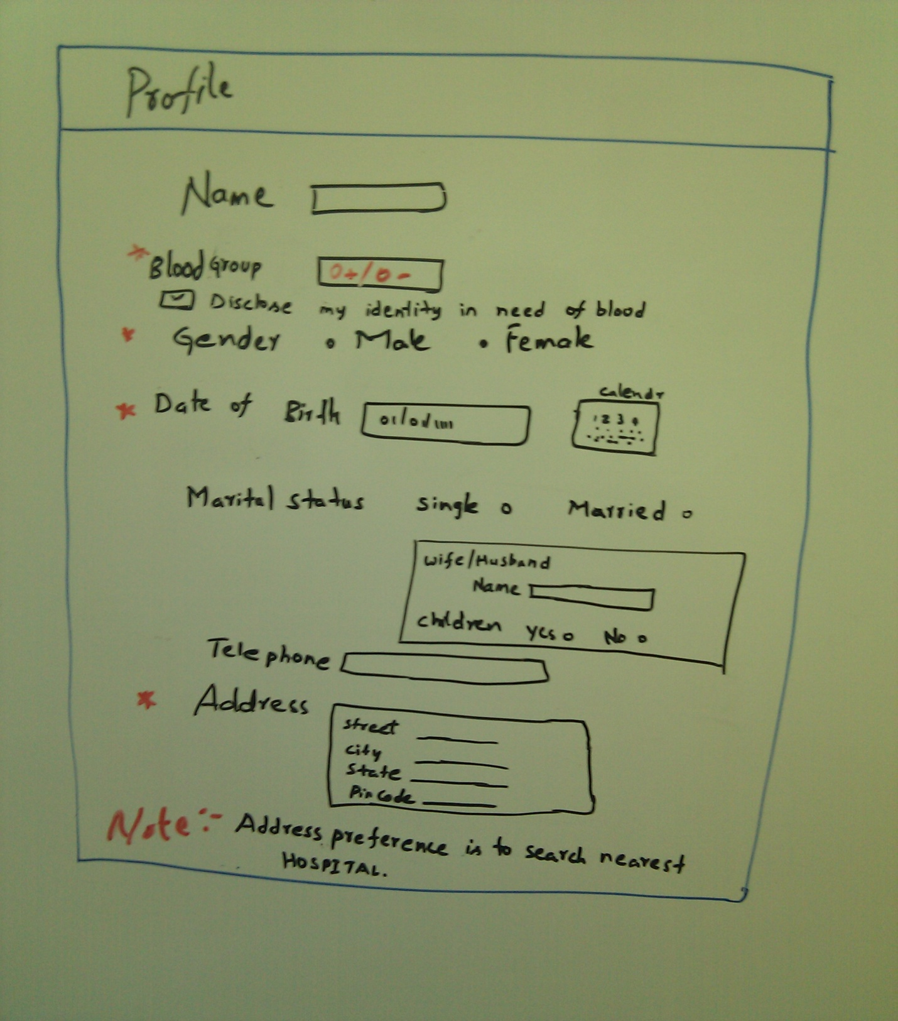The profile page provides basic information of the user

After the user logs into our application he will be directed to the Home page.

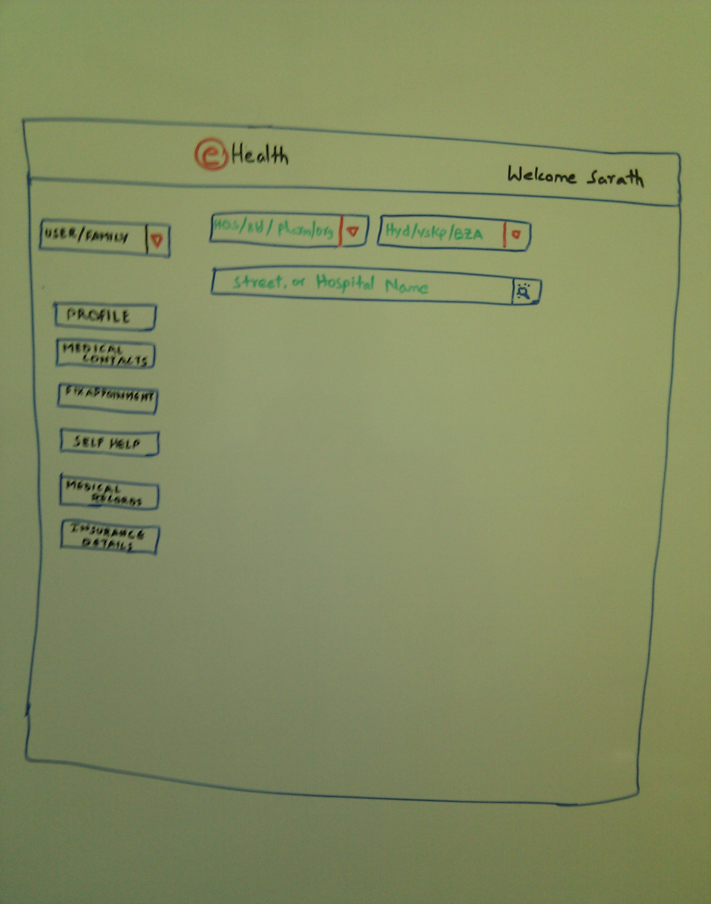

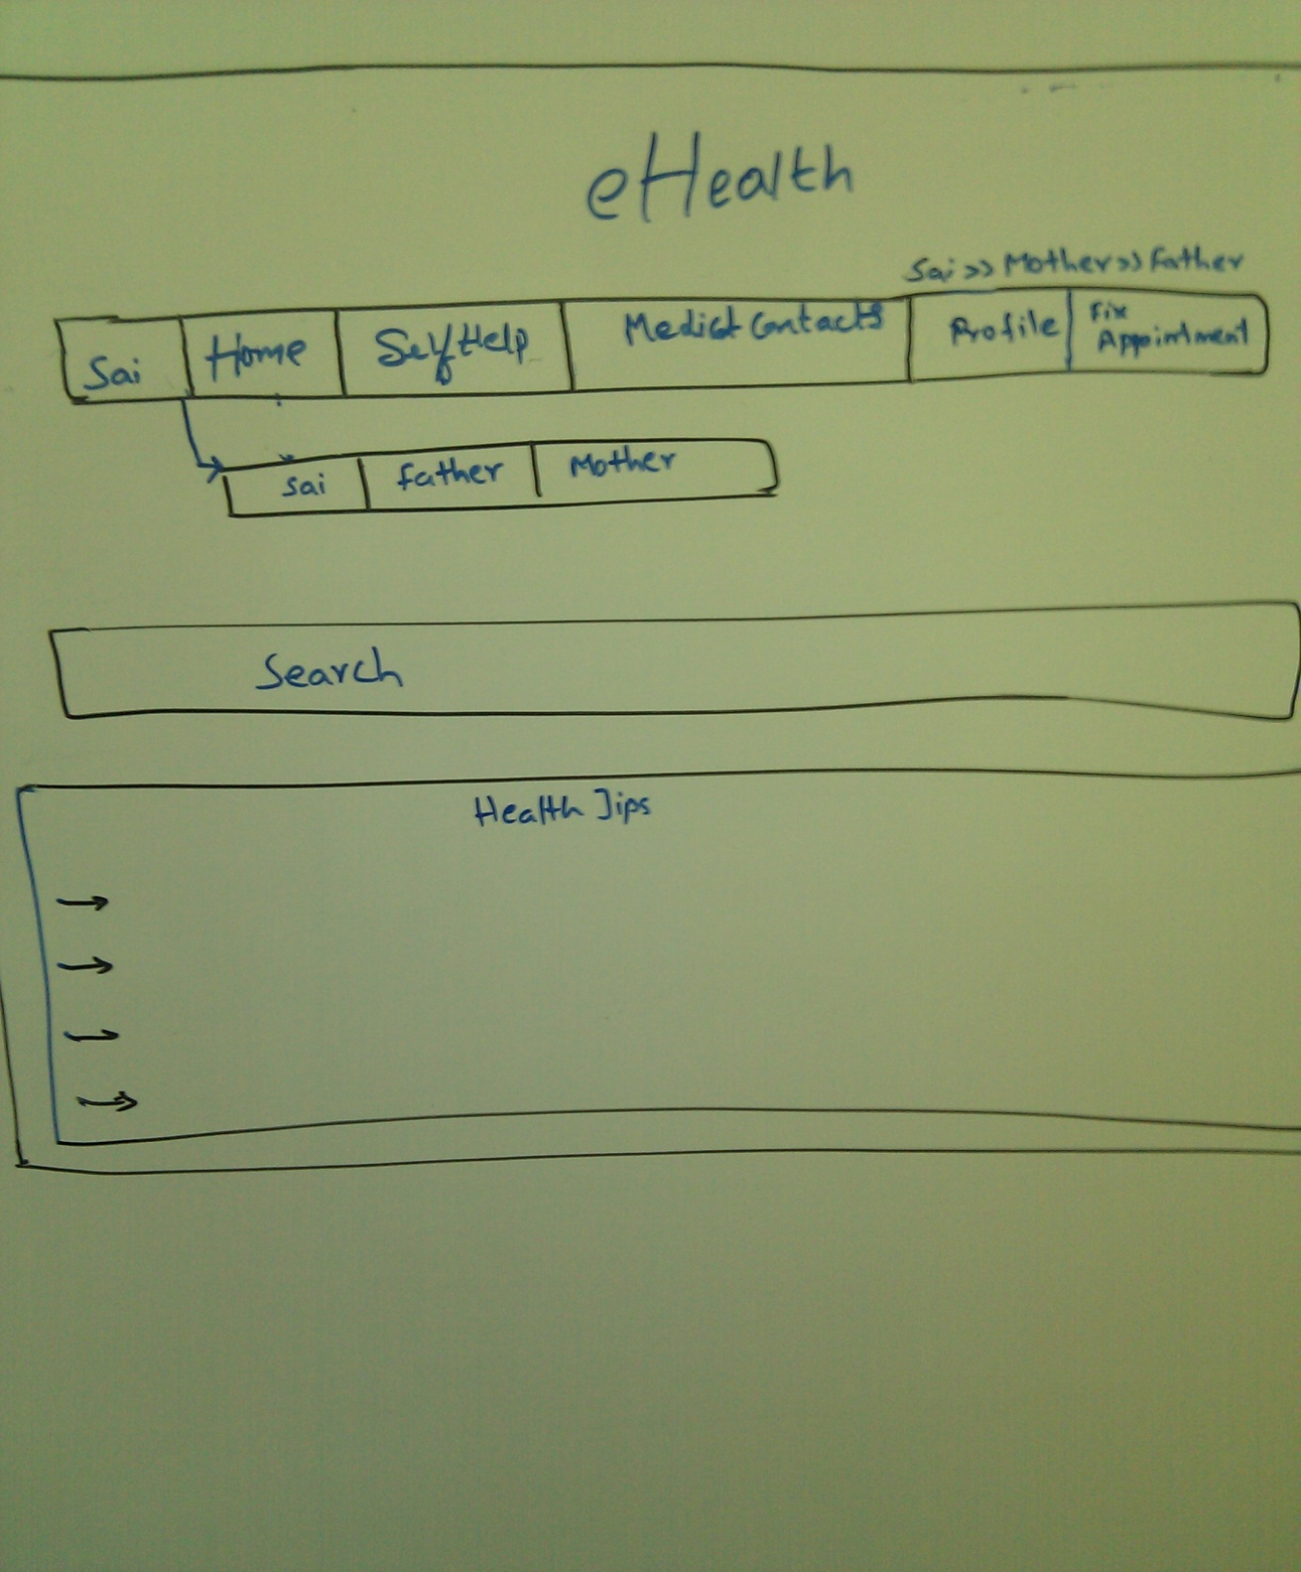

This page shows the navigation of the user.

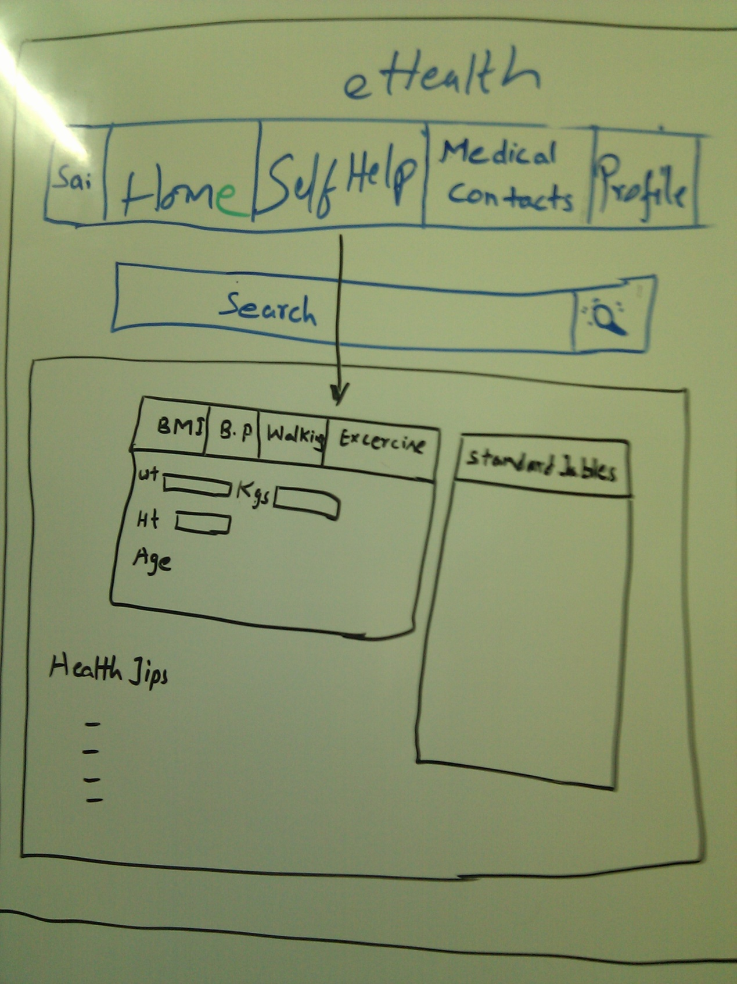

In self help the user can check his status where he can take care of his health using these standard tables, by comparing the entered data.